**Integration Github with Azure Pipelines**

**Overview**

**GitHub** hosts over 100 million repositories containing applications of all shapes and sizes. But GitHub is just a start—those applications still need to get built, released, and managed to reach their full potential.

[Azure Pipelines](https://azure.microsoft.com/services/devops/pipelines/) that enables you to continuously build, test, and deploy to any platform or cloud. It has cloud-hosted agents for Linux, macOS, and Windows; powerful workflows with native container support; and flexible deployments to Kubernetes, VMs, and serverless environments.

Azure Pipelines provides unlimited CI/CD minutes and 10 parallel jobs to every GitHub open source project for free. All open source projects run on the same infrastructure that our paying customers use. That means you’ll have the same fast performance and high quality of service. Many of the top open source projects are already using Azure Pipelines for CI/CD, such as Atom, CPython, Pipenv, Tox, Visual Studio Code, and TypeScript—and the list is growing every day.

In this lab, you’ll see how easy it is to set up **Azure Pipelines** with your **GitHub** projects and how you can achieve an end-to-end traceability from work items to code change, commit, to build and release.

**Setups**

**ARM Outputs extension**

<https://marketplace.visualstudio.com/items?itemName=keesschollaart.arm-outputs>

**Git installed from**

<https://git-scm.com/downloads>

**Visual Studio Code**

<https://code.visualstudio.com>

**Azure Pipelines extension for Visual Studio Code**

<https://marketplace.visualstudio.com/items?itemName=ms-azure-devops.azure-pipelines>

**GitHub Pull Requests extension for Visual Studio Code**

<https://marketplace.visualstudio.com/items?itemName=GitHub.vscode-pull-request-github>

**Load Sample Project**

Open <https://github.com> and sign in with your credentials

Open <https://github.com/Microsoft/ContosoAir/>

Click Fork option

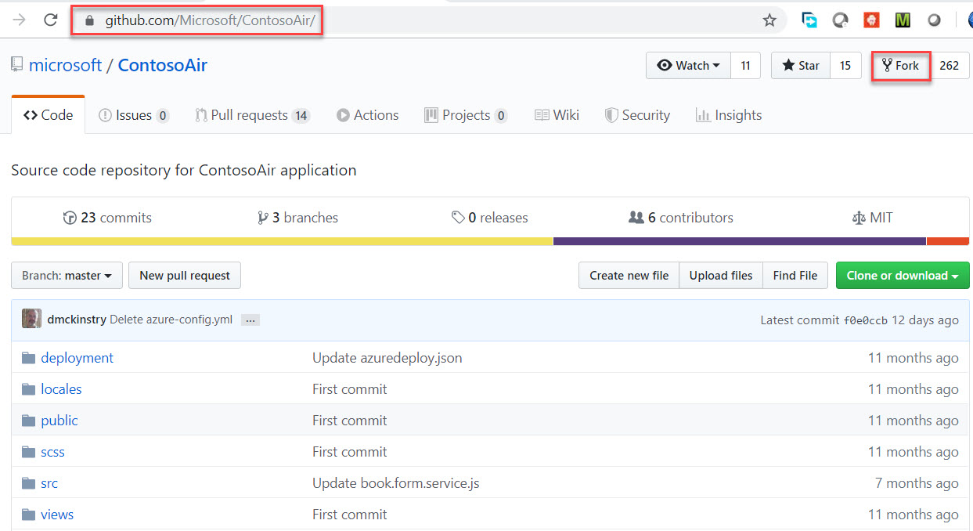

Click on Clone or download button -> Click on Copy

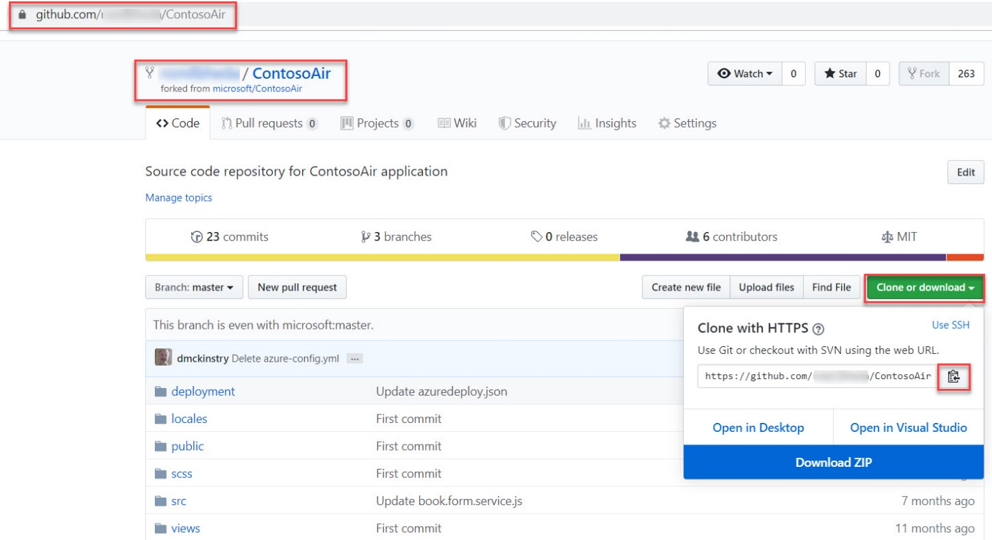

Start Visual Studio Code

View -> Command Palette… option

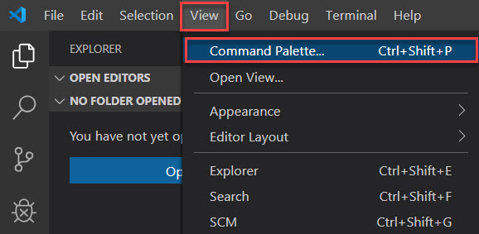

Type **git clone** and click on result

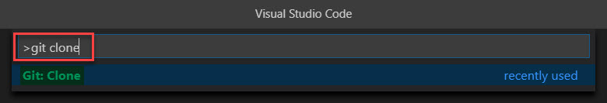

Paste that Github repo link and press enter

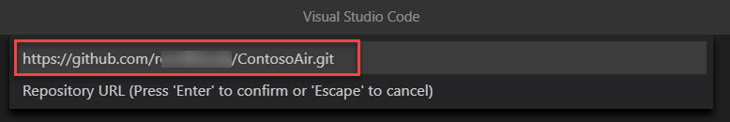

Select your repo location in local system.

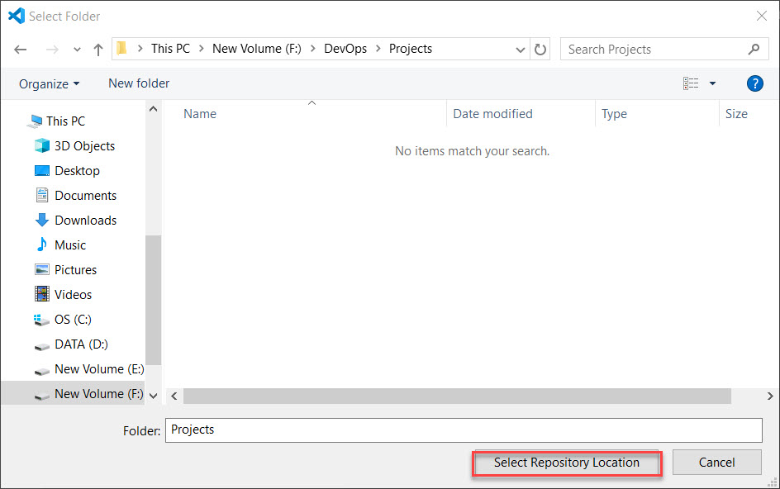

Click on Open button

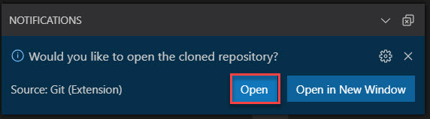

Navigate to github.com and select Marketplace option

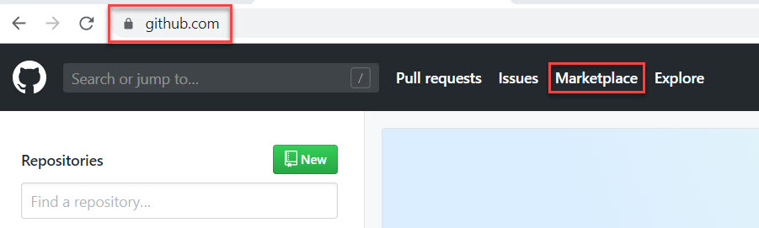

Search for “azure pipelines” and select Azure Pipelines

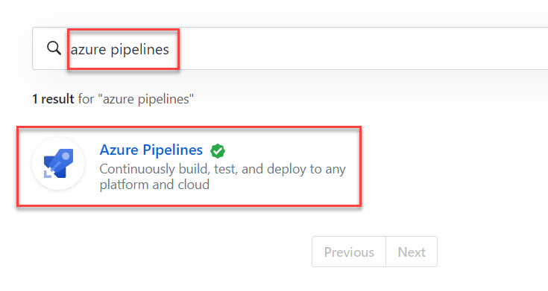

Click on **Set up a plan** button

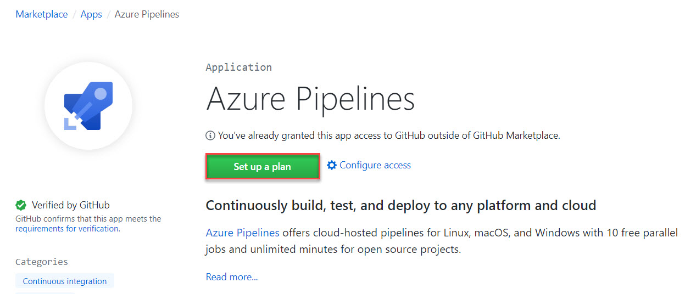

Click on **Install it for free**

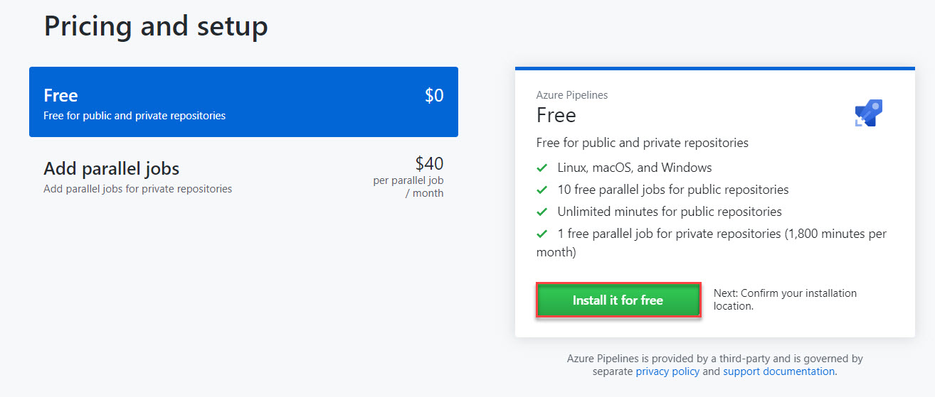

Click on **Complete order and begin installation** button

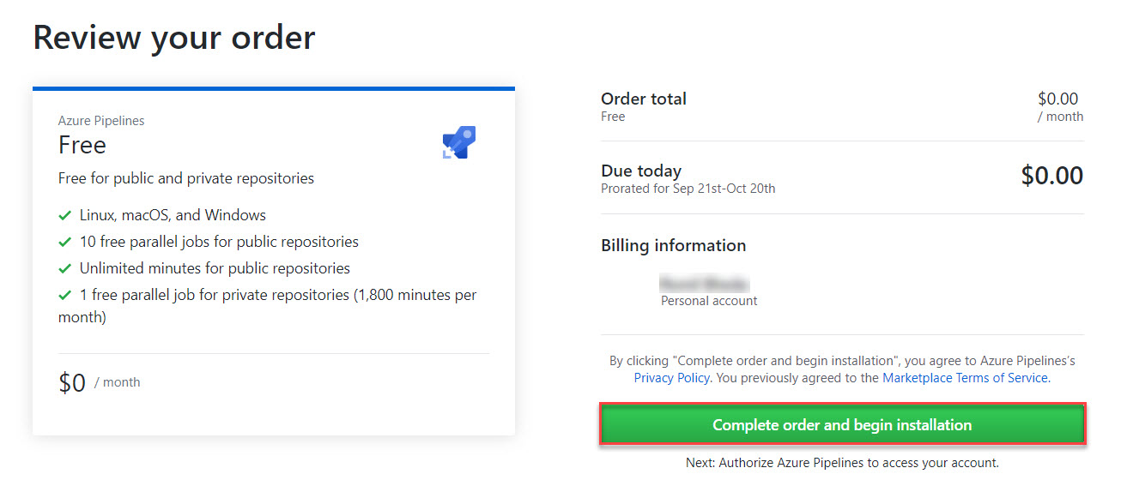

Select your repository Ex. **ContosoAir**

Click on **Save** button

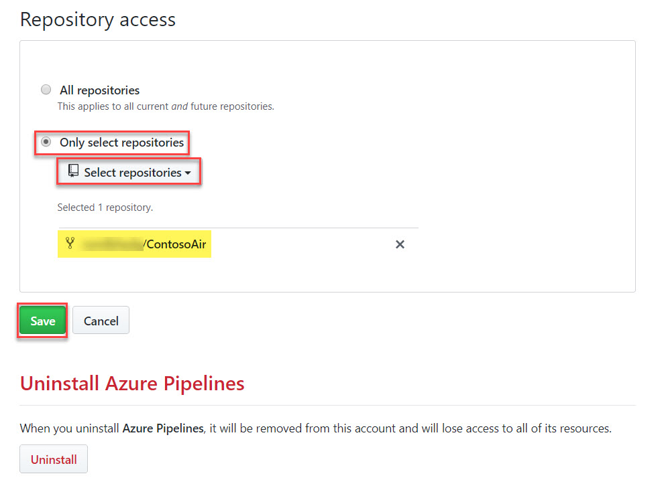

Enter Credentials

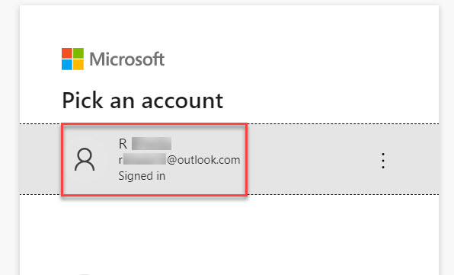

Select Organization from list

Click on **Create a new project** option

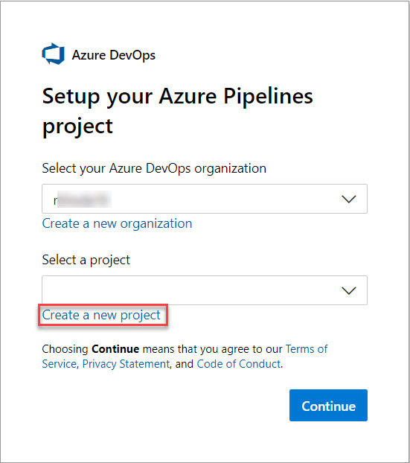

Enter Project Name: MyContosoAirProject

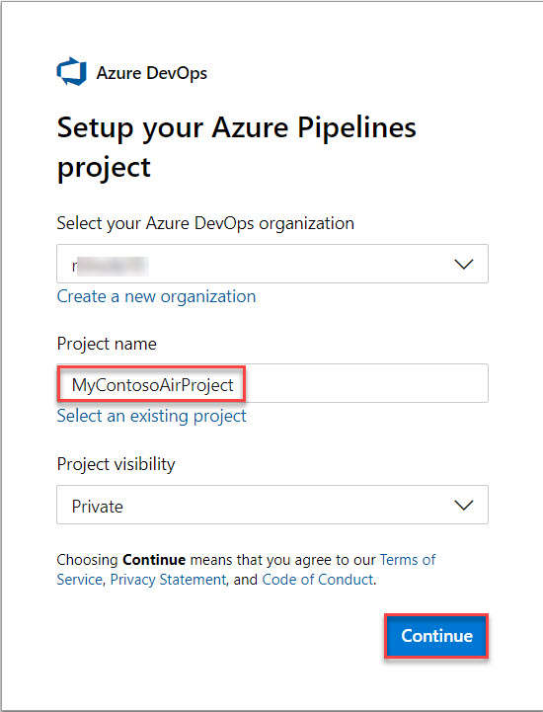

Select ContosoAir repo

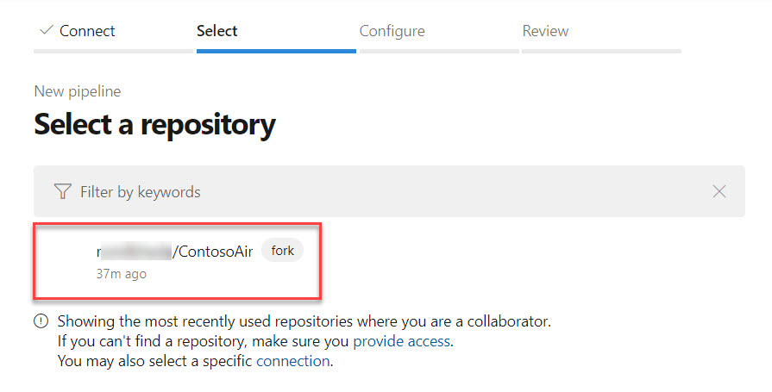

Select Node.js

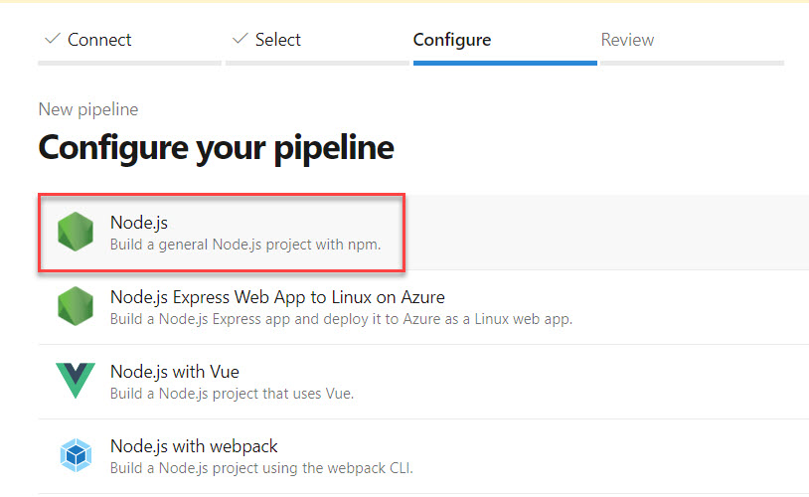

Update with below code:

pool:

vmImage: 'ubuntu-16.04'

trigger:

- master

steps:

- task: CopyFiles@2

displayName: 'Copy Files to: $(build.artifactstagingdirectory)/Templates'

inputs:

SourceFolder: deployment

Contents: '*.json'

TargetFolder: '$(build.artifactstagingdirectory)/Templates'

- task: Npm@1

displayName: 'npm custom'

inputs:

command: custom

verbose: false

customCommand: 'install --production'

- task: ArchiveFiles@2

displayName: 'Archive $(Build.SourcesDirectory)'

inputs:

rootFolderOrFile: '$(Build.SourcesDirectory)'

includeRootFolder: false

- task: PublishBuildArtifacts@1

displayName: 'Publish Artifact: drop'

Click on Save and run button.

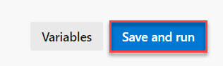

Commit message: Set up CI with Azure Pipelines

Select **Commit directly to the master branch.**

Click on **Save and Run** button

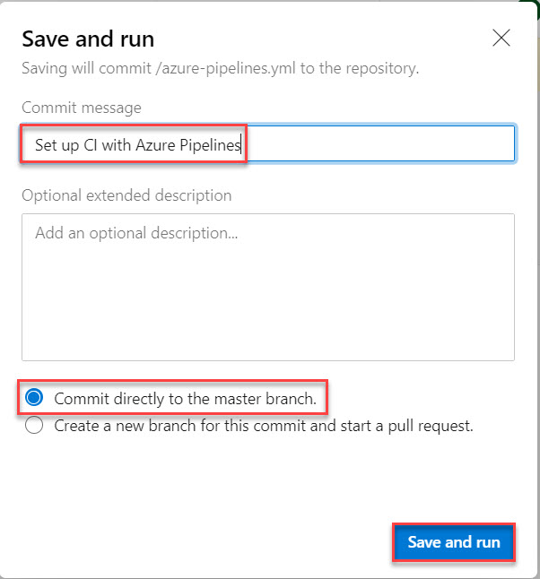

Wait for few minutes to build the project

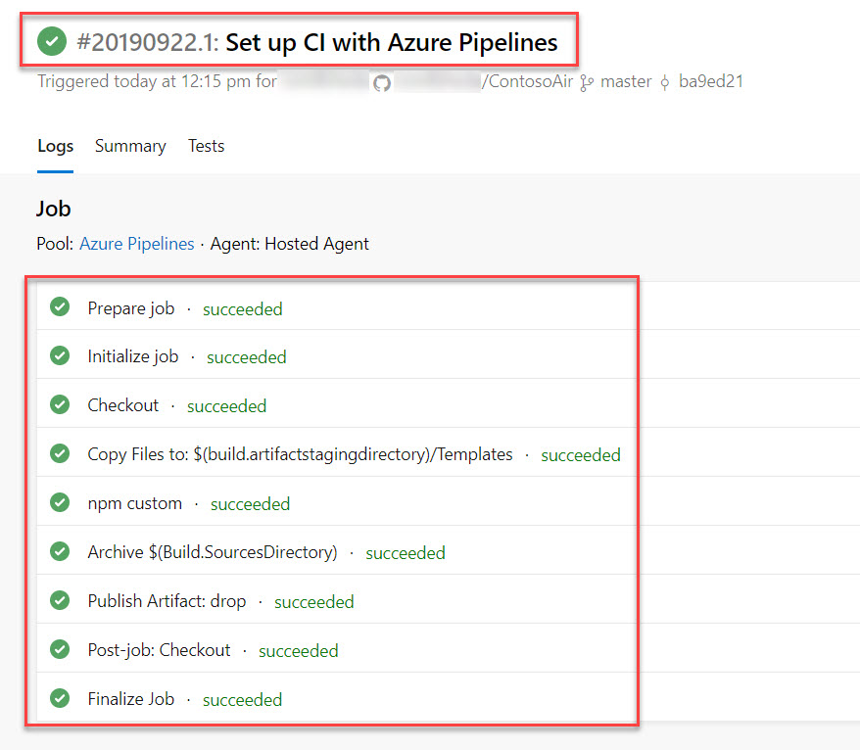

Click on Build Ex. abc.ContosoAir

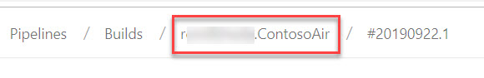

Click on Vertical dots and Select **Status Badge** option

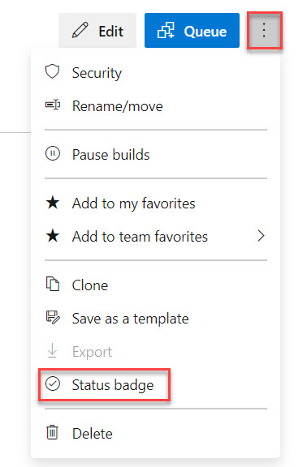

Check Sample markdown and copy

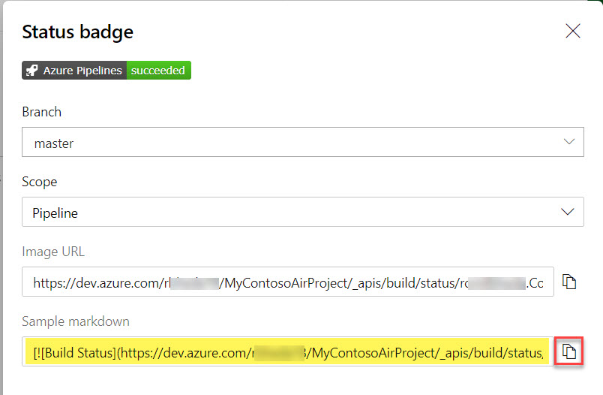

Navigate to Visual Studio Code

Expand ContosoAir Project and open README.md file

Paste badge code

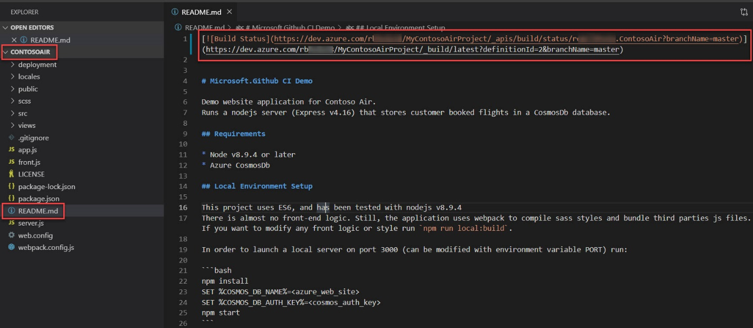

Click on Source Control and write **Added build status badge**

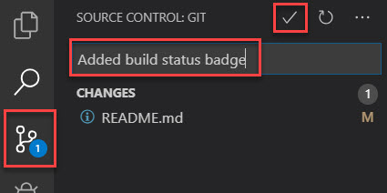Click on **Tick icon**

Click on **Always** button

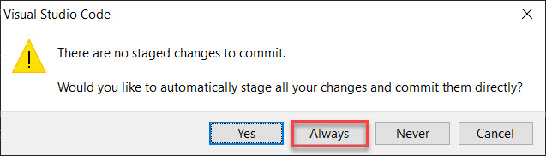\

Check bottom-left side of Visual Studio code and click on Changes icons



Click on Ok button to Push

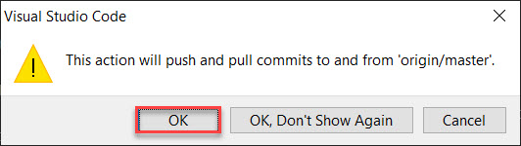

Check README.md file. Badge Available

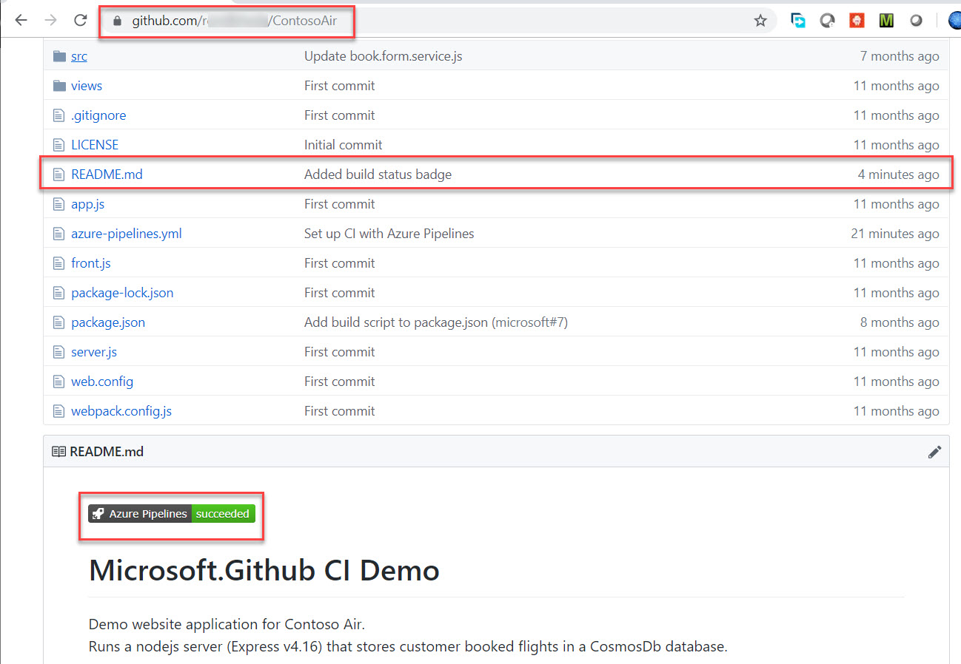

Select Explorer and Open azure-pipelines.yml

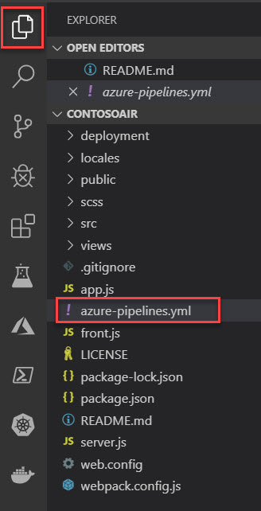

Replace with below code

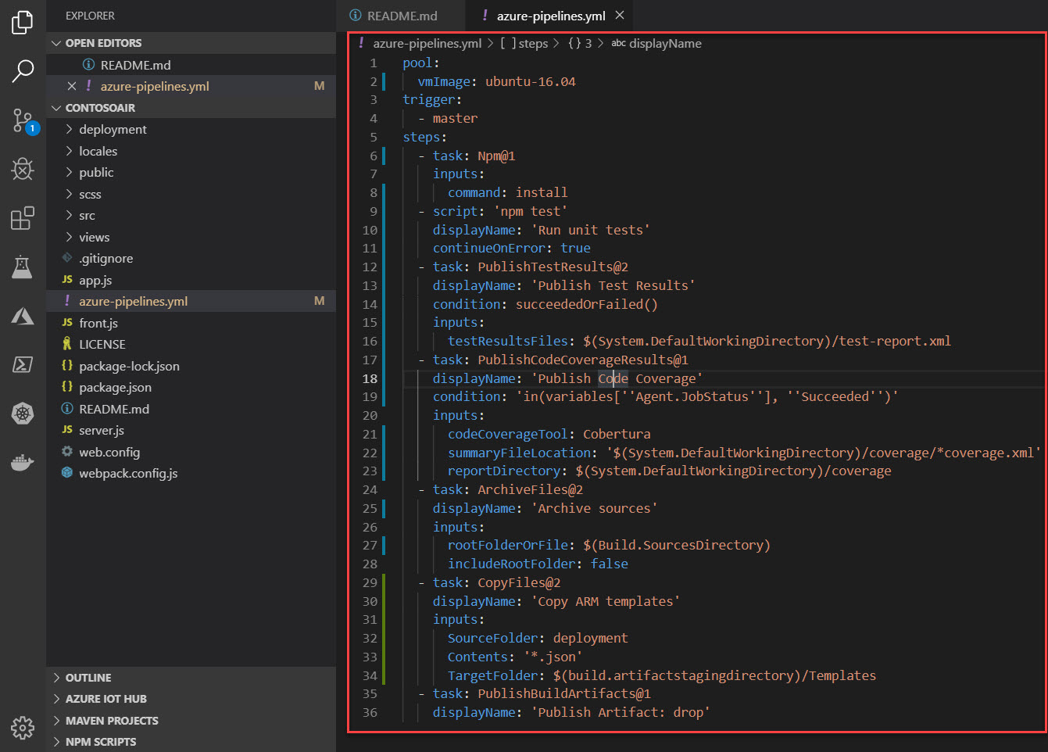

pool:

vmImage: ubuntu-16.04

trigger:

- master

steps:

- task: Npm@1

inputs:

command: install

- script: 'npm test'

displayName: 'Run unit tests'

continueOnError: true

- task: PublishTestResults@2

displayName: 'Publish Test Results'

condition: succeededOrFailed()

inputs:

testResultsFiles: $(System.DefaultWorkingDirectory)/test-report.xml

- task: PublishCodeCoverageResults@1

displayName: 'Publish Code Coverage'

condition: 'in(variables[''Agent.JobStatus''], ''Succeeded'')'

inputs:

codeCoverageTool: Cobertura

summaryFileLocation: '$(System.DefaultWorkingDirectory)/coverage/*coverage.xml'

reportDirectory: $(System.DefaultWorkingDirectory)/coverage

- task: ArchiveFiles@2

displayName: 'Archive sources'

inputs:

rootFolderOrFile: $(Build.SourcesDirectory)

includeRootFolder: false

- task: CopyFiles@2

displayName: 'Copy ARM templates'

inputs:

SourceFolder: deployment

Contents: '*.json'

TargetFolder: $(build.artifactstagingdirectory)/Templates

- task: PublishBuildArtifacts@1

displayName: 'Publish Artifact: drop'

Click on Source Control and write message: **Updated build pipeline**.

Click on Tick icon

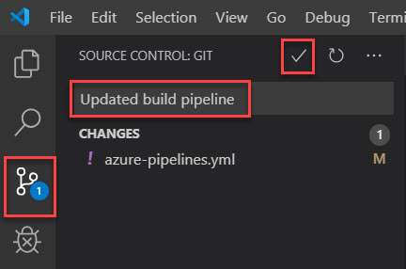

Once again click on Chnages.

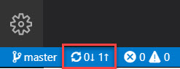

Click on OK button

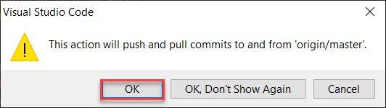

Navigate to Azure DevOps portal and check pipeline – Updated build pipeline

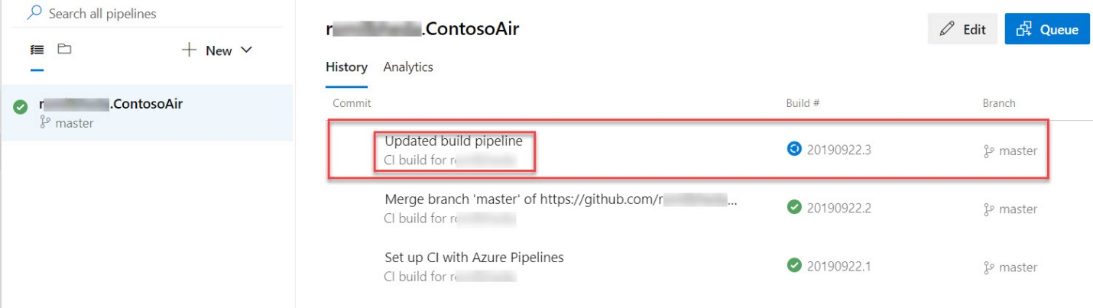

Wait for few minutes to complete job

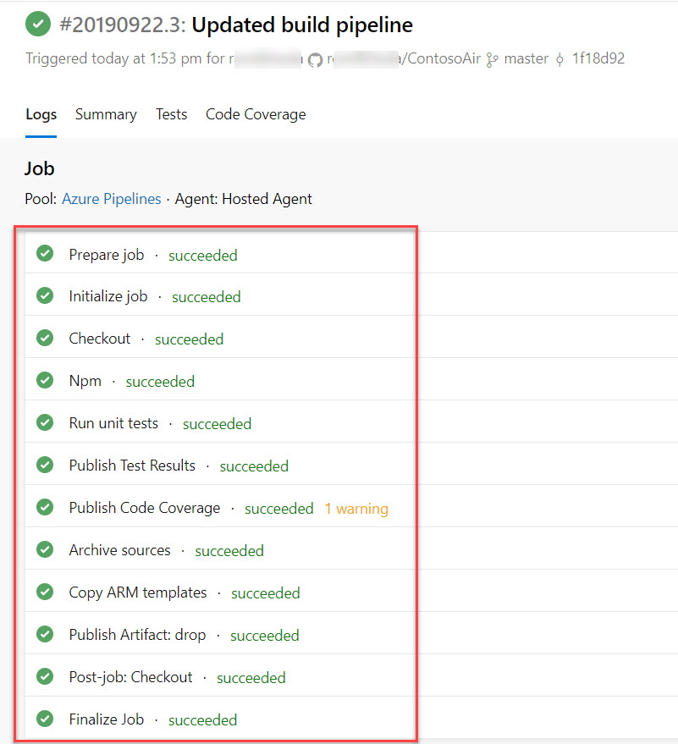

Click on Tests

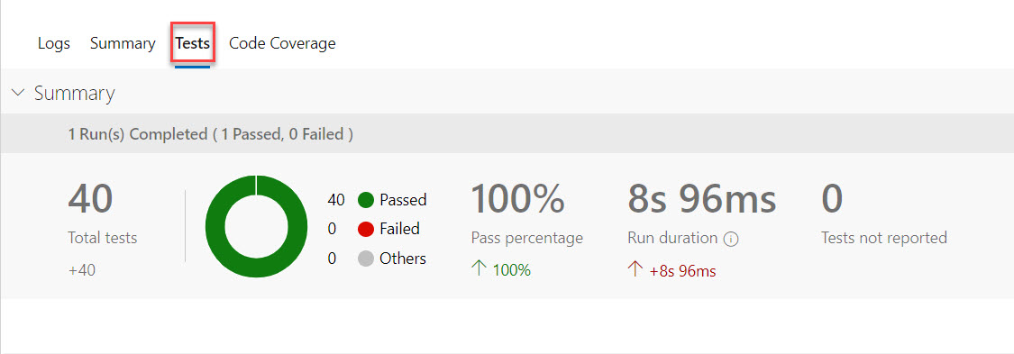

Click on Outcome and add Passed option. Result available

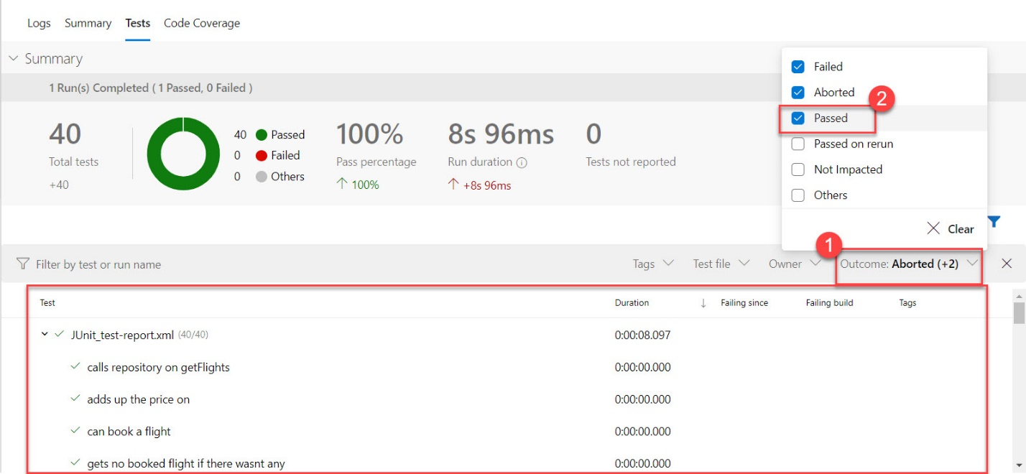

Click on Release

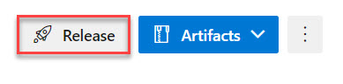

Click on **Empty Job**

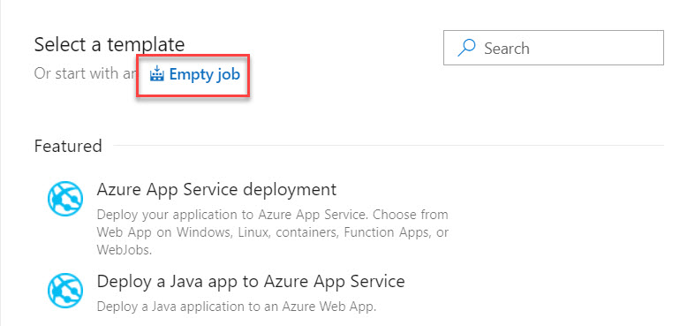

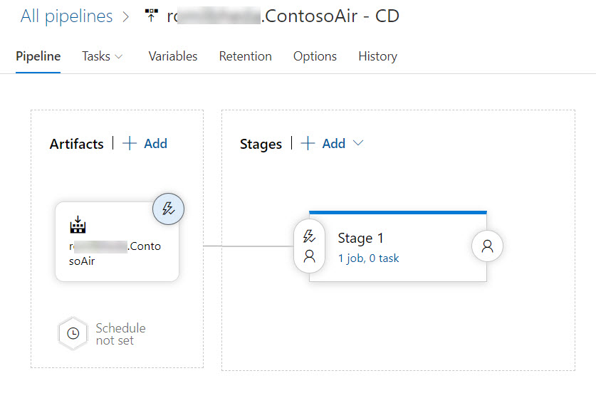

Click on variables -> + Add option

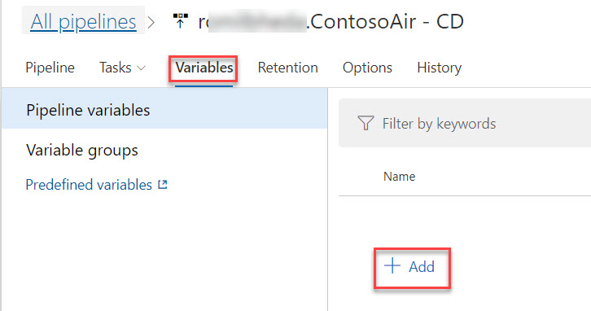

Name: resourcegroup

Value: contosoair

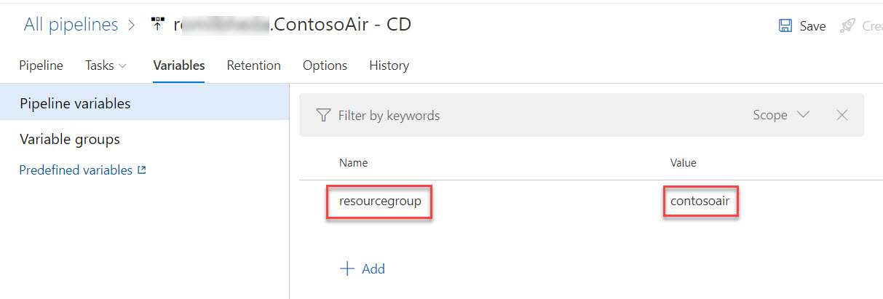

Click on Tasks -> + Add -> search for “resource”

Select Azure resource group deployment and click on Add button

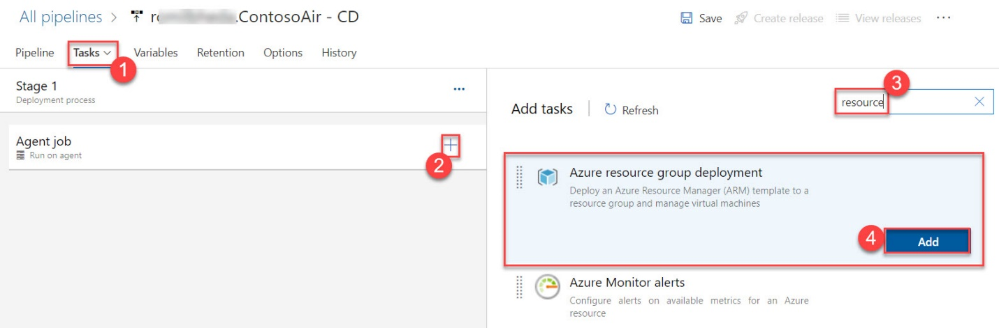

Select your subscription

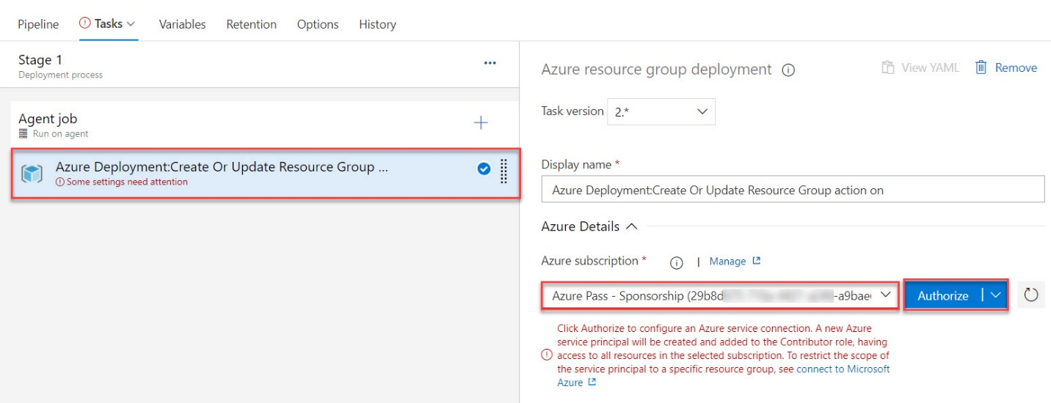

Enter Credentials

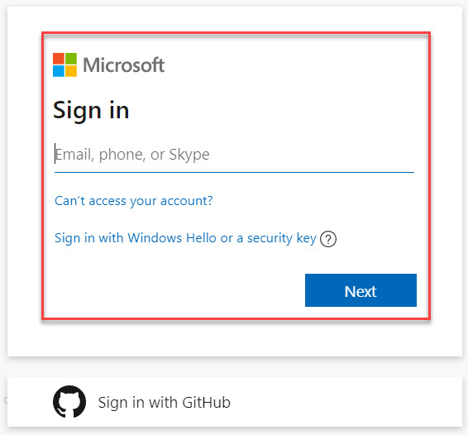

Click on **+** and add search for **arm**

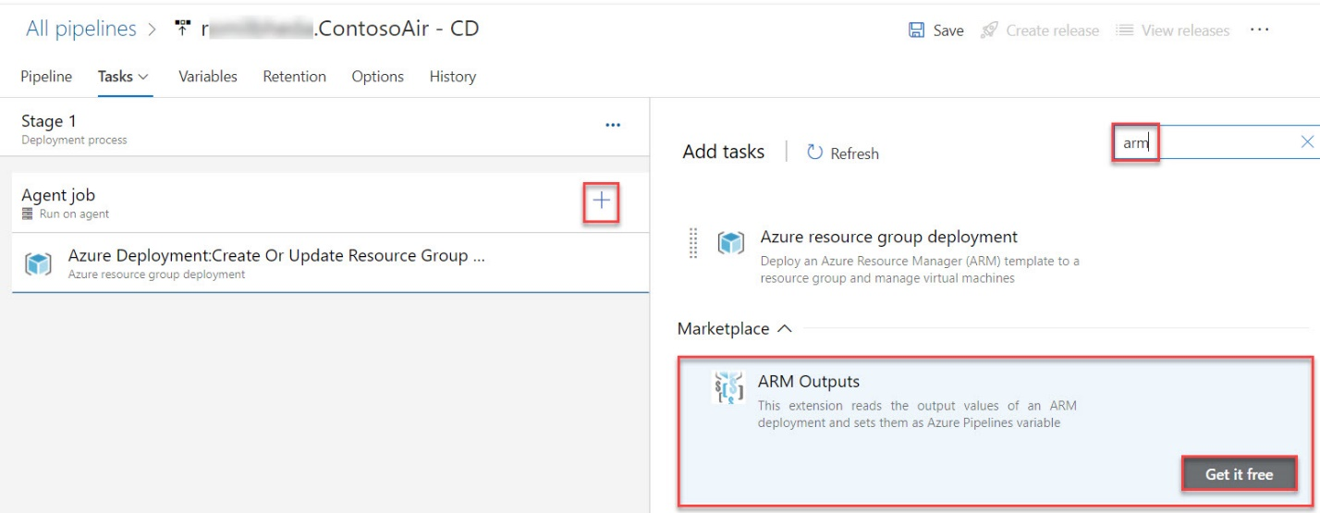

Click on Get it free

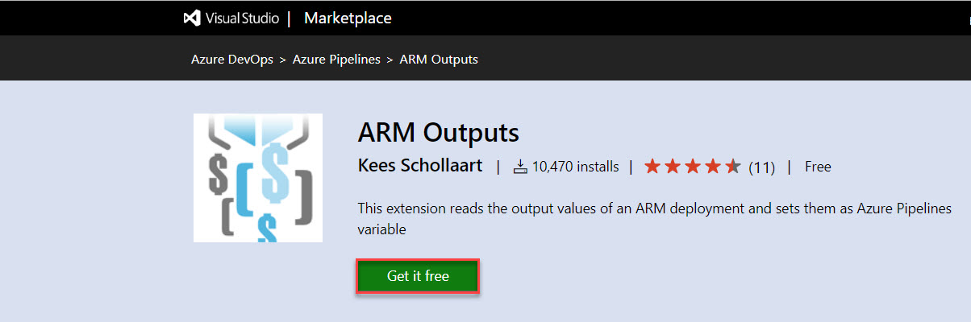

Install

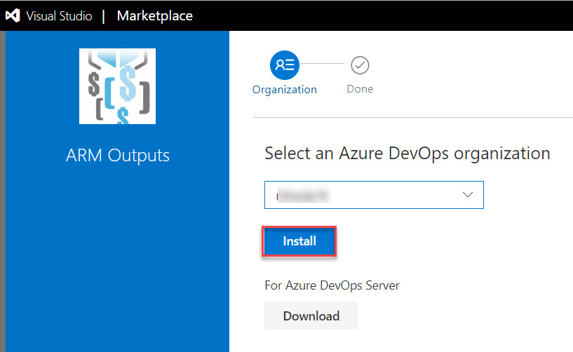

Back to your ARM Output and click on Add option

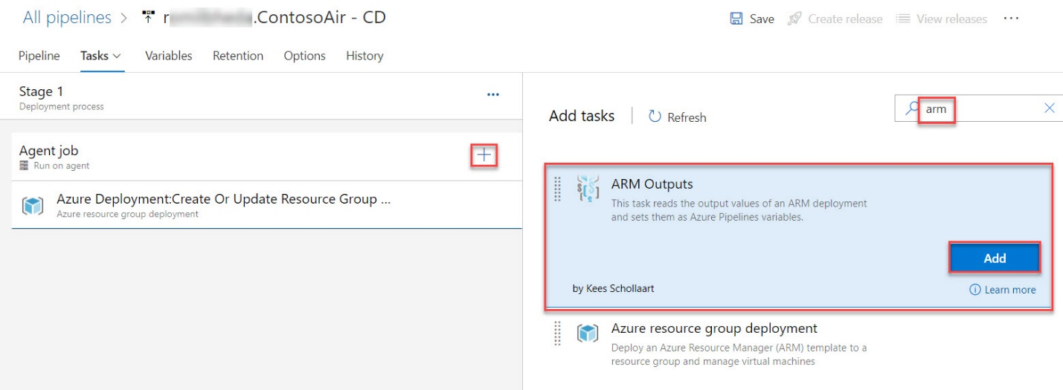

Select Azure Subscription

Resource Group: **$(resourcegroup)**

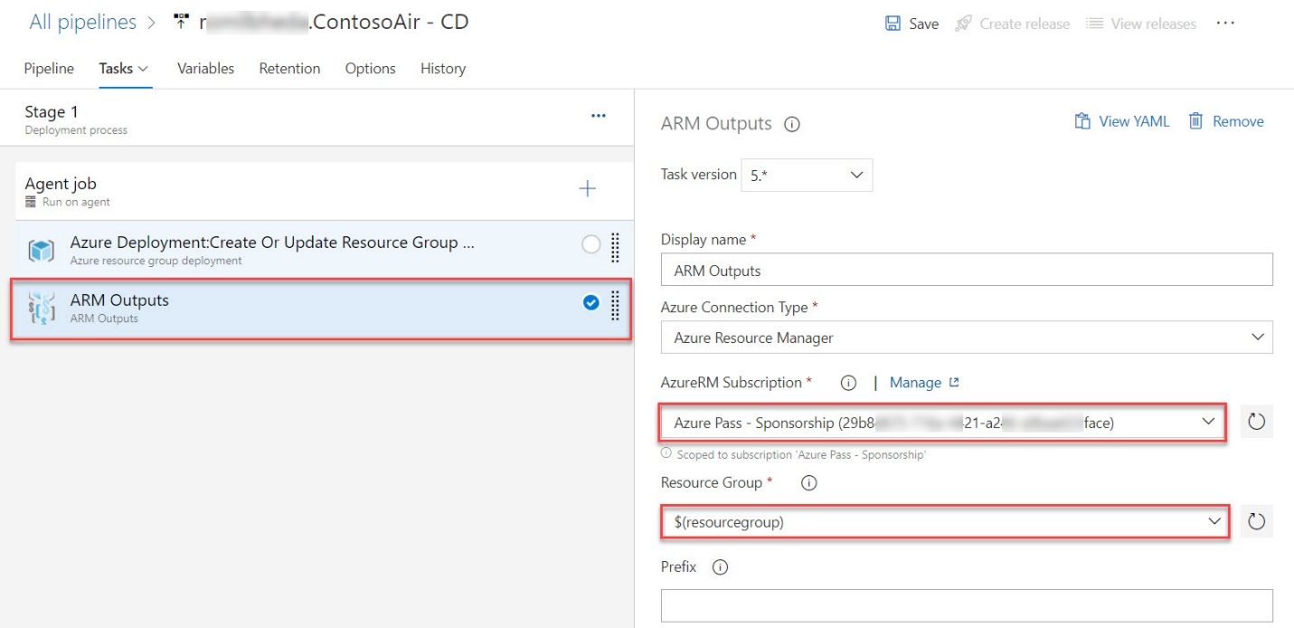

Add on more job. Search for app service

Click on Add

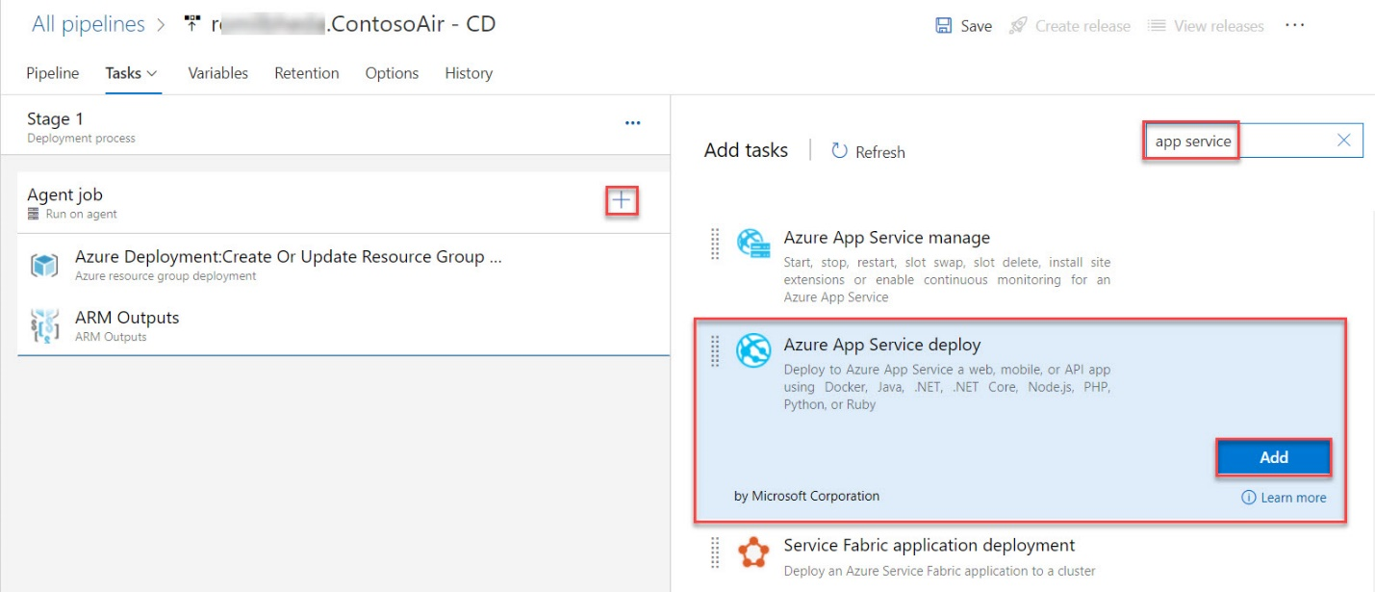

Action: **Create or update resource group**

Resource group: **$(resourcegroup)**

Location: **Any location**

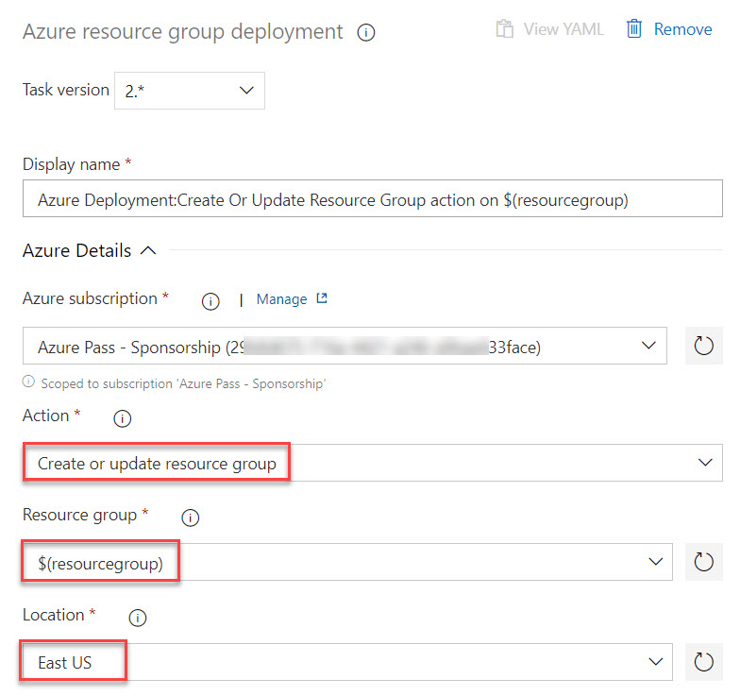

Template – Select Browse option

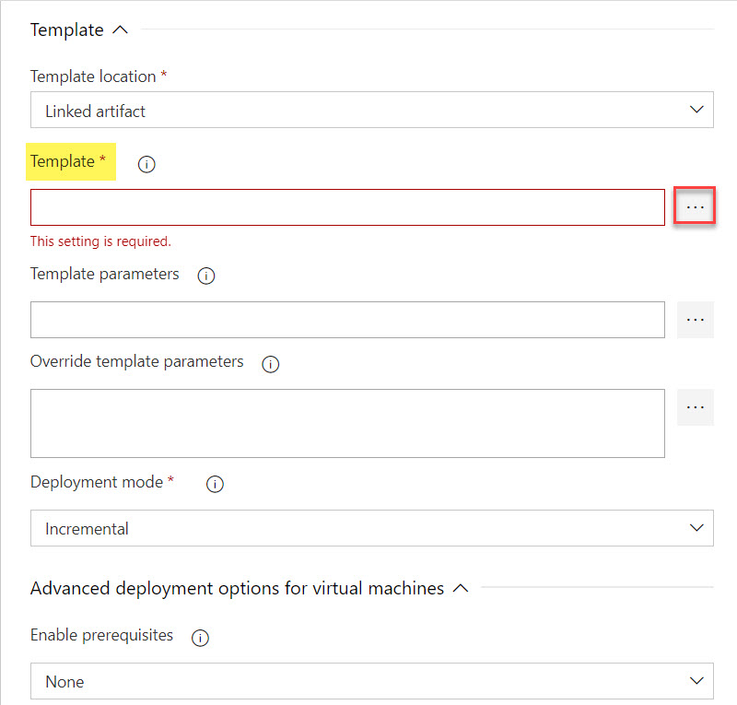

Expand and select **azuredeploy.json** file

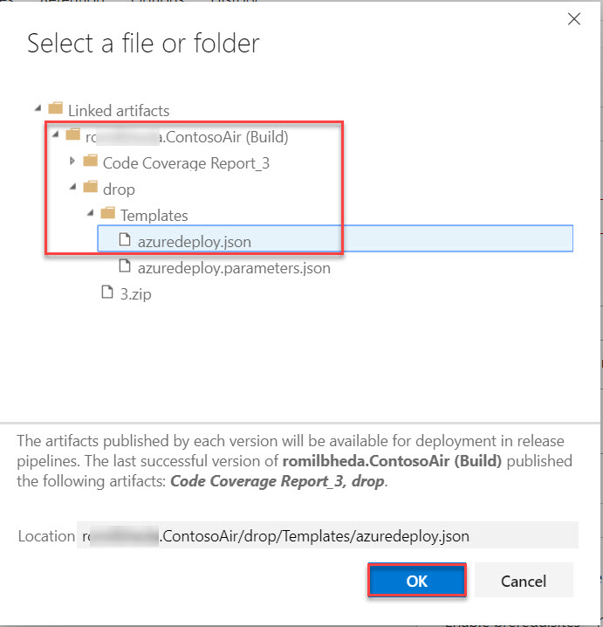

Template Parameters – Browse option

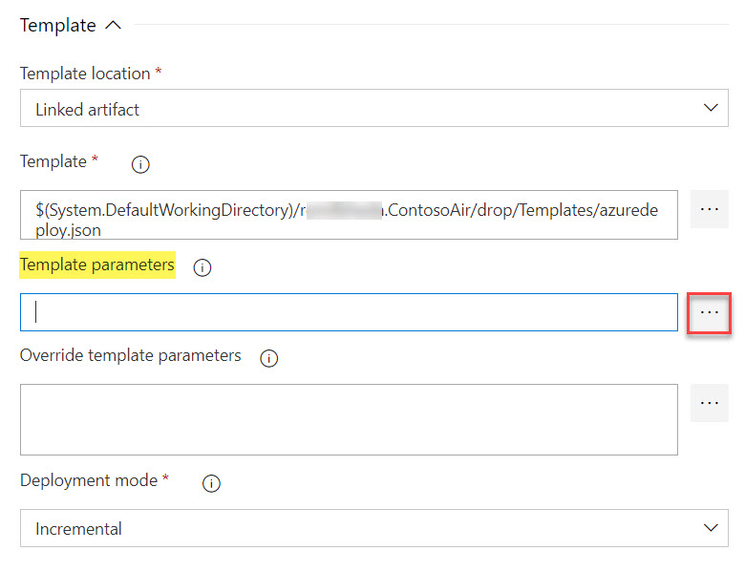

Expand and select **azuredeploy.parameters.json** file

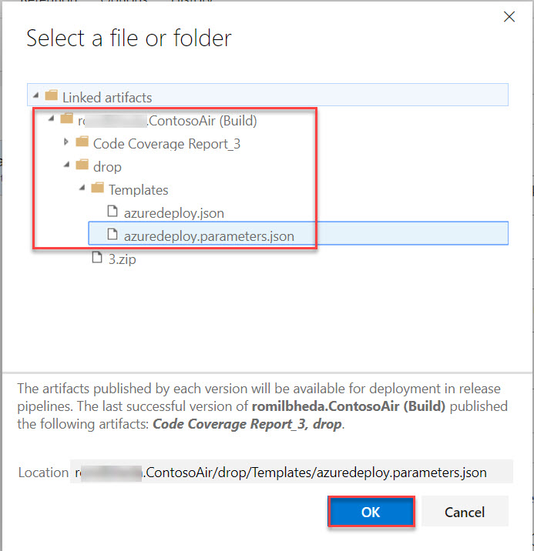

Add template parameters (App unique name)

**-p_environment rwebdemo**

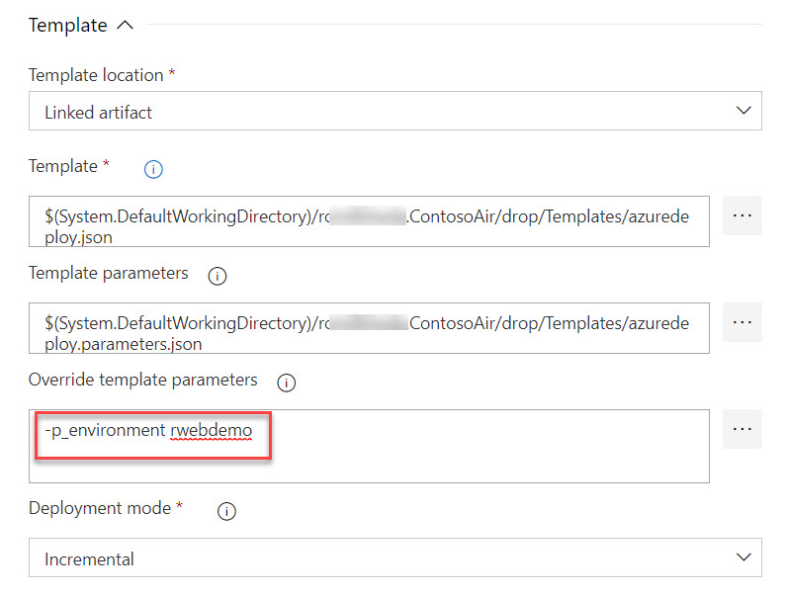

Select **Azure App Service Deploy**

Select **Subscription**

App Service type: **Web App on Windows**

App Service Name: **$(web)**

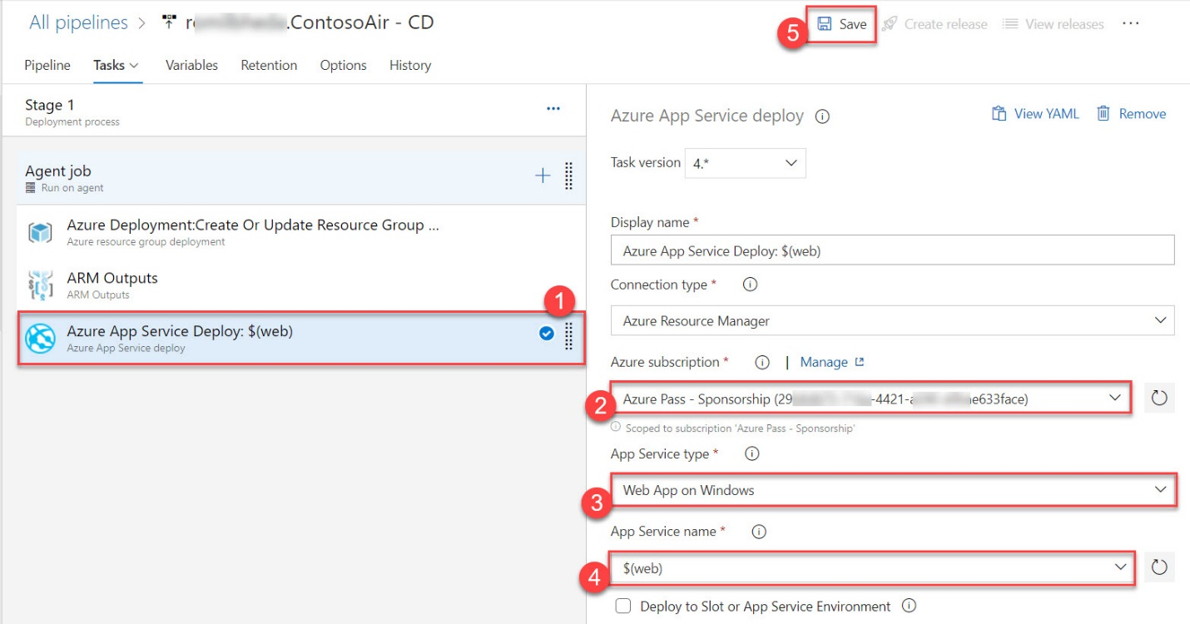

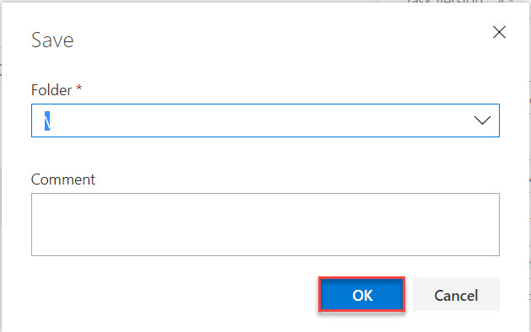

Click on Create release option



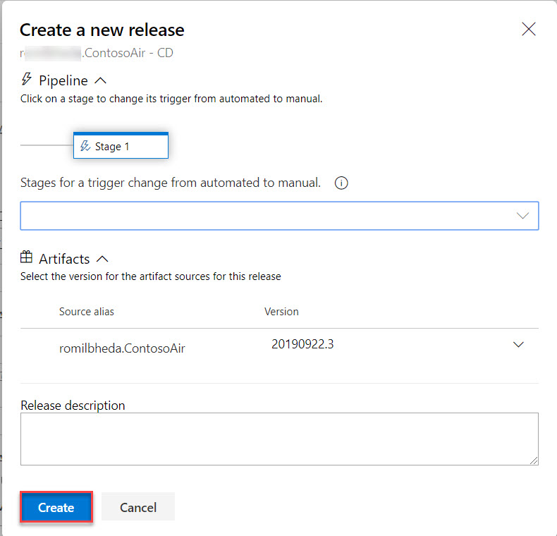

Click on Release-x option

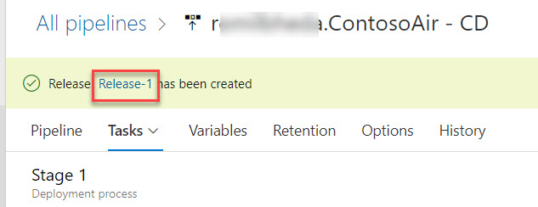

Logs

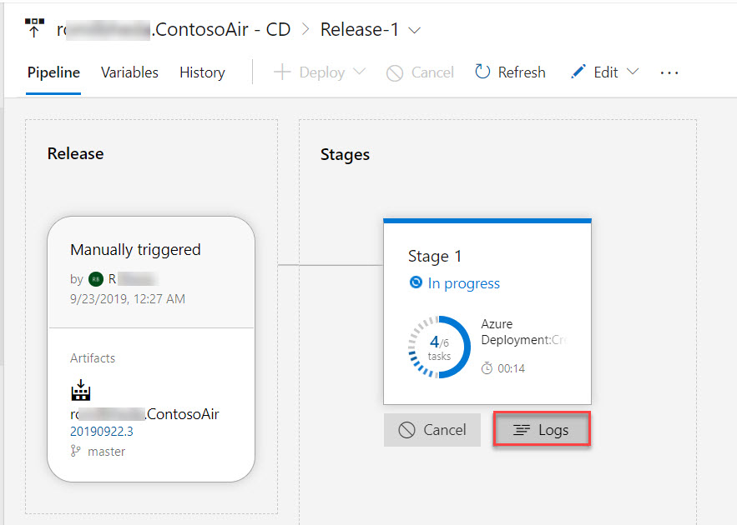

Click on Azure App Service Deploy: $(web) task

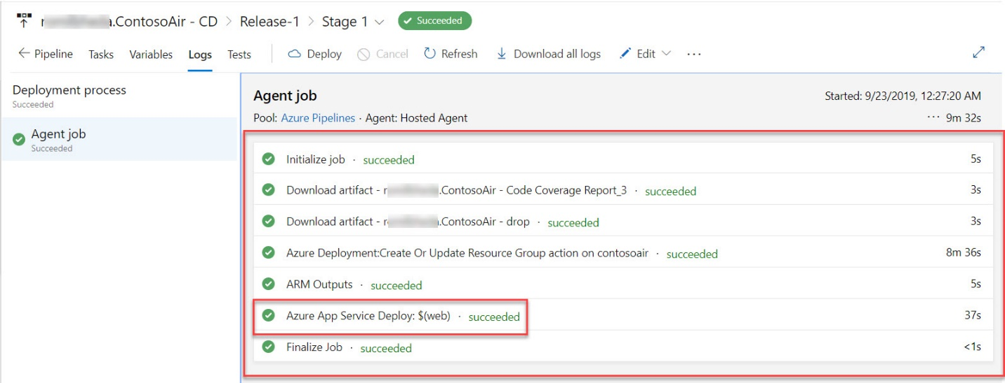

Click on App Service Application URL

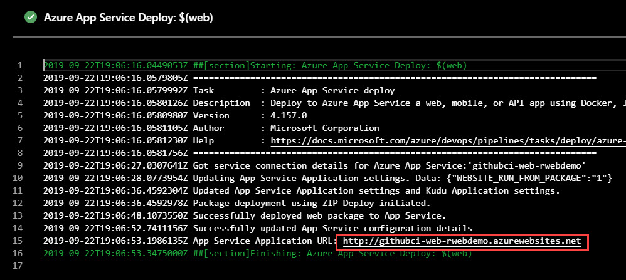

Project is running

